# Relational Databases and SQL Course 2020-2021

Home Exercise 3

1. In this question you are going to change data in the sakila database for the first time. In the film table there is a column called original_language_id which currently only contains null values.
   1. Write and run an UPDATE command that, for every row in the film table, sets the value of its original_language_id to a random number between 1 and 6 (including 6).
   2. Explain why I ask for this specific range of numbers (1-6).
   3. Write a SELECT query that returns a list of all films. The result should have three columns:

* Column title should contain the title of the film.
* Column language should contain the name of the language of the film
* Column original_language should contain the name of the original language of the film but if the original language is the same as the language the value here should be 'Same'.

Here is an example of the expected output:

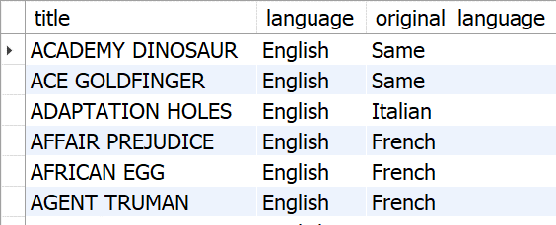

1. In the sakila database every film can have multiple categories that it belongs to. Every film can also have multiple actors that participated in it. We would like to know for each category which actors played in films belonging to that category.

Write a SELECT query that returns one row for each category. The result should have two columns:

* + Column name should contain the name of the category.
  + Column actors should contain a comma (,) separated list of distinct actor names.

Here is an example of the expected output:

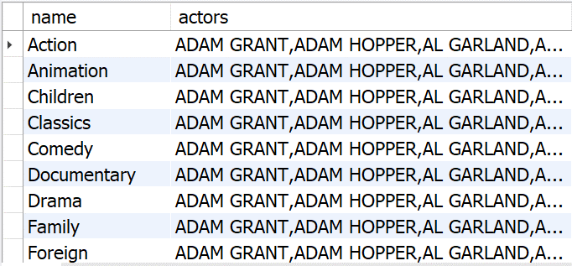

Hint: For the second column find a MySQL function that lets you concatenate grouped values.

Good luck!

* EOF -